Notch Subtraction

Definition
# Source: AI Source: Provided by: [Data Path: Persons Table -> ID Column: 1, Name_En Column: Motasem Essam] -> From: [ChatGPT] on [7/25/2026]
Notch Subtraction is a method of forming a modified solid by removing material from an edge, corner, or boundary region of an existing solid, creating an indentation or cut-out that changes its original external shape.
Unlike a surface depression, which is generally formed within an outer face, a notch typically extends inward from an edge or boundary and is open to the exterior through one or more sides.
The resulting solid has a missing section along its boundary.

Simple Definition
# Source: AI Source: Provided by: [Data Path: Persons Table -> ID Column: 1, Name_En Column: Motasem Essam] -> From: [ChatGPT] on [7/25/2026]
Notch subtraction means removing material from an edge, corner, or side of a solid to create an open cut-out or indentation.

Geometric Representation
# Source: AI Source: Provided by: [Data Path: Persons Table -> ID Column: 1, Name_En Column: Motasem Essam] -> From: [ChatGPT] on [7/25/2026]
A notch can be formed in different positions and geometric shapes.
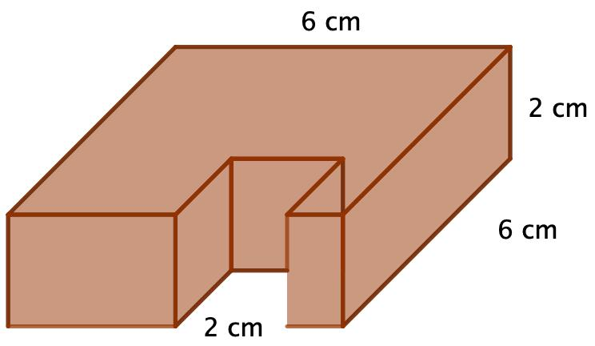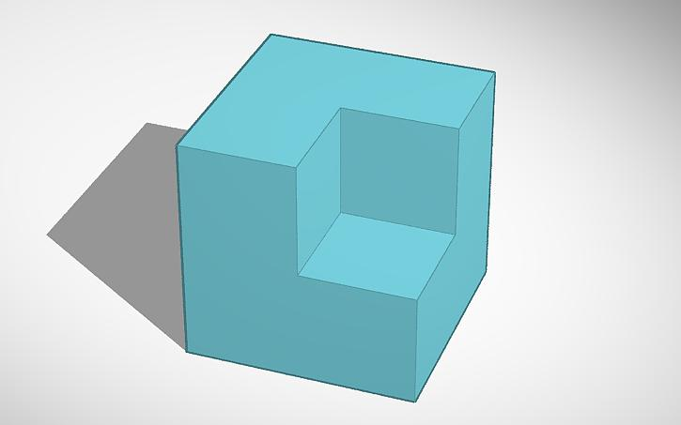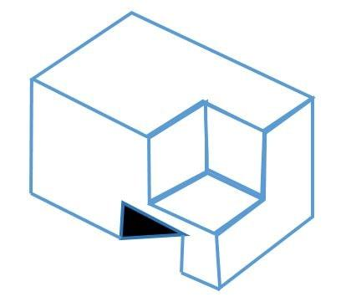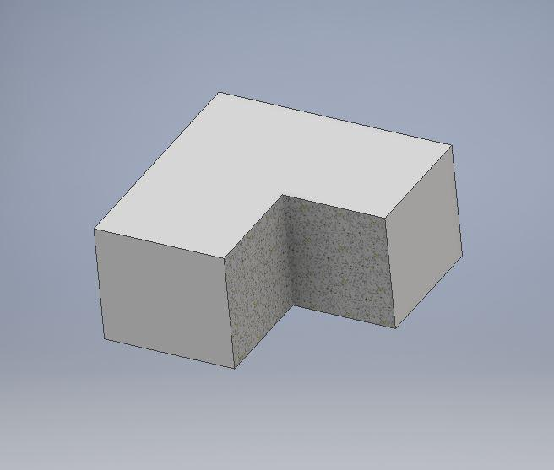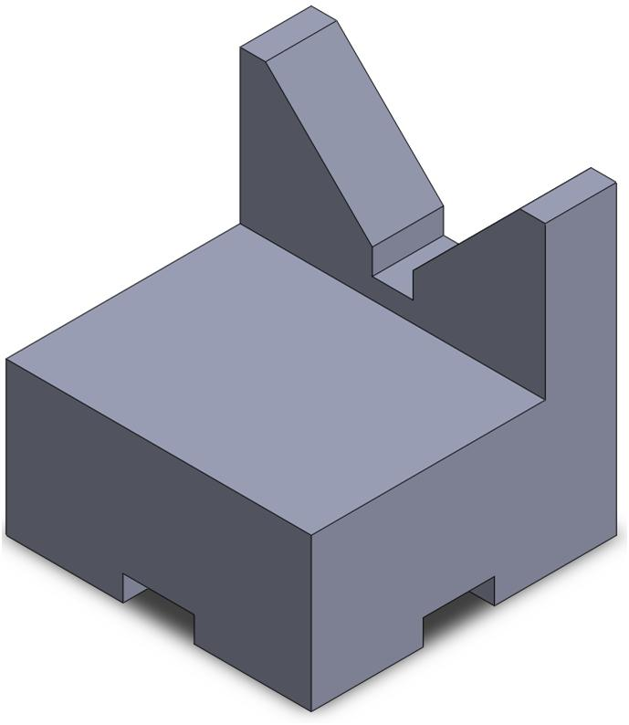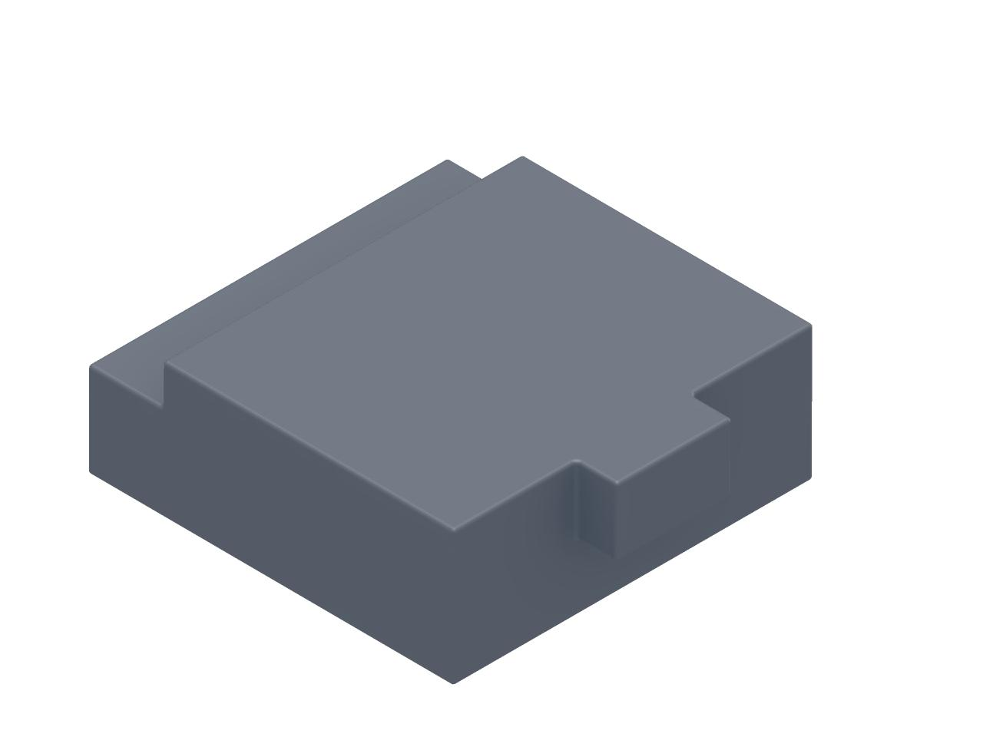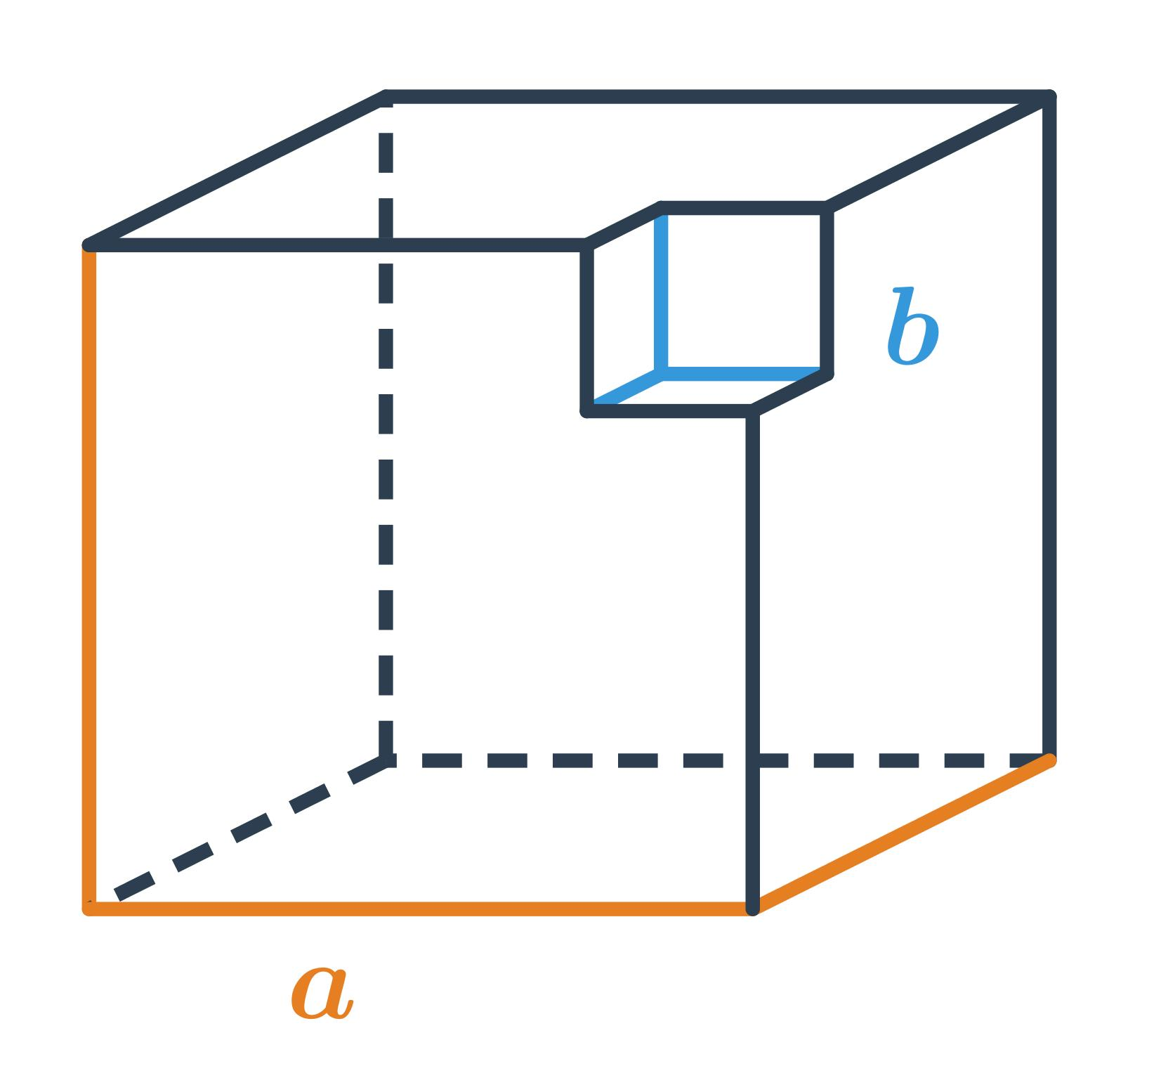
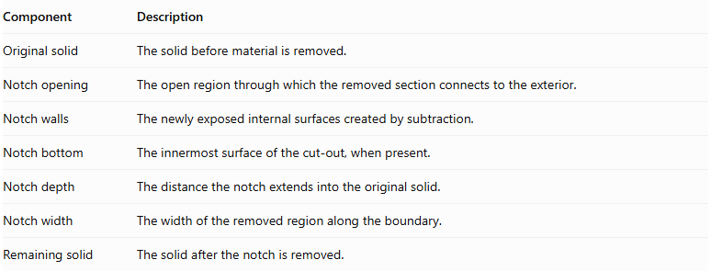
Component | Description
Original solid | The solid before material is removed.
Notch opening | The open region through which the removed section connects to the exterior.
Notch walls | The newly exposed internal surfaces created by subtraction.
Notch bottom | The innermost surface of the cut-out, when present.
Notch depth | The distance the notch extends into the original solid.
Notch width | The width of the removed region along the boundary.
Remaining solid | The solid after the notch is removed.

Main Classification
# Source: AI Source: Provided by: [Data Path: Persons Table -> ID Column: 1, Name_En Column: Motasem Essam] -> From: [ChatGPT] on [7/25/2026]
Notch subtraction can be classified according to the geometric shape of the removed region.

Rectangular Notch Subtraction
# Source: AI Source: Provided by: [Data Path: Persons Table -> ID Column: 1, Name_En Column: Motasem Essam] -> From: [ChatGPT] on [7/25/2026]
Material is removed from an edge or side of a solid to create a rectangular cut-out.
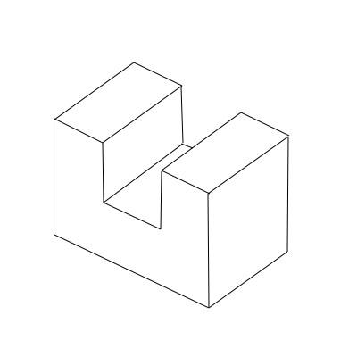
- Opening: Rectangular.
- Walls: Usually flat and perpendicular.
- Bottom: Usually rectangular.
- Example: A rectangular cut-out along the upper edge of a prism.

Square Notch Subtraction
# Source: AI Source: Provided by: [Data Path: Persons Table -> ID Column: 1, Name_En Column: Motasem Essam] -> From: [ChatGPT] on [7/25/2026]
Material is removed to create a square-shaped notch.
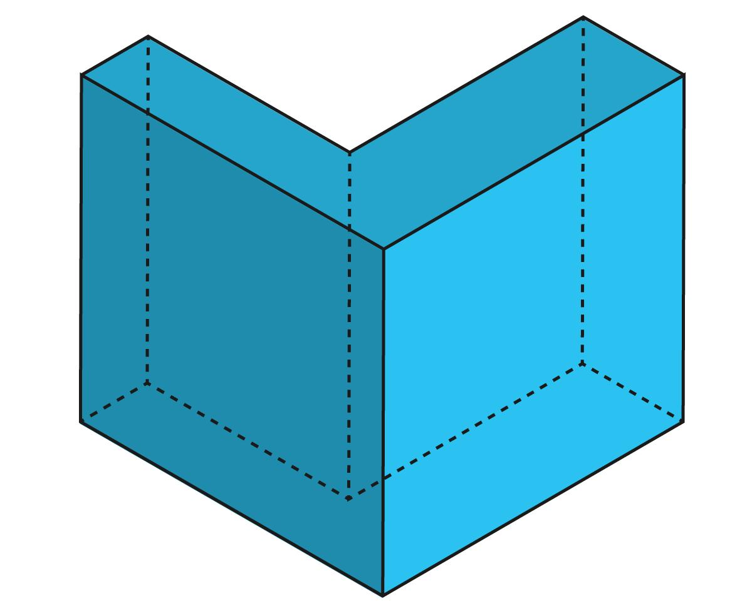
- Opening: Square.
- Walls: Usually rectangular.
- Cross-section: Square.
- Example: A square cut-out from the corner of a cube.

Triangular Notch Subtraction
# Source: AI Source: Provided by: [Data Path: Persons Table -> ID Column: 1, Name_En Column: Motasem Essam] -> From: [ChatGPT] on [7/25/2026]
Material is removed in a triangular shape from an edge or boundary.
- Opening: Triangular.
- Walls: Usually triangular or rectangular, depending on the cutting direction.
- Example: A triangular notch along the edge of a prism.

V-Shaped Notch Subtraction
# Source: AI Source: Provided by: [Data Path: Persons Table -> ID Column: 1, Name_En Column: Motasem Essam] -> From: [ChatGPT] on [7/25/2026]
Material is removed to form a V-shaped indentation.
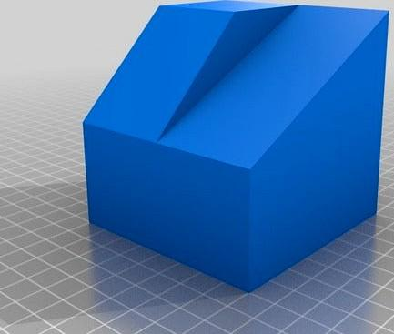
- Opening: V-shaped.
- Walls: Usually two inclined planar surfaces.
- Bottom: A line or narrow region, depending on the cut.
- Example: A V-shaped notch cut into a block.

U-Shaped Notch Subtraction
# Source: AI Source: Provided by: [Data Path: Persons Table -> ID Column: 1, Name_En Column: Motasem Essam] -> From: [ChatGPT] on [7/25/2026]
Material is removed to create a U-shaped cut-out.
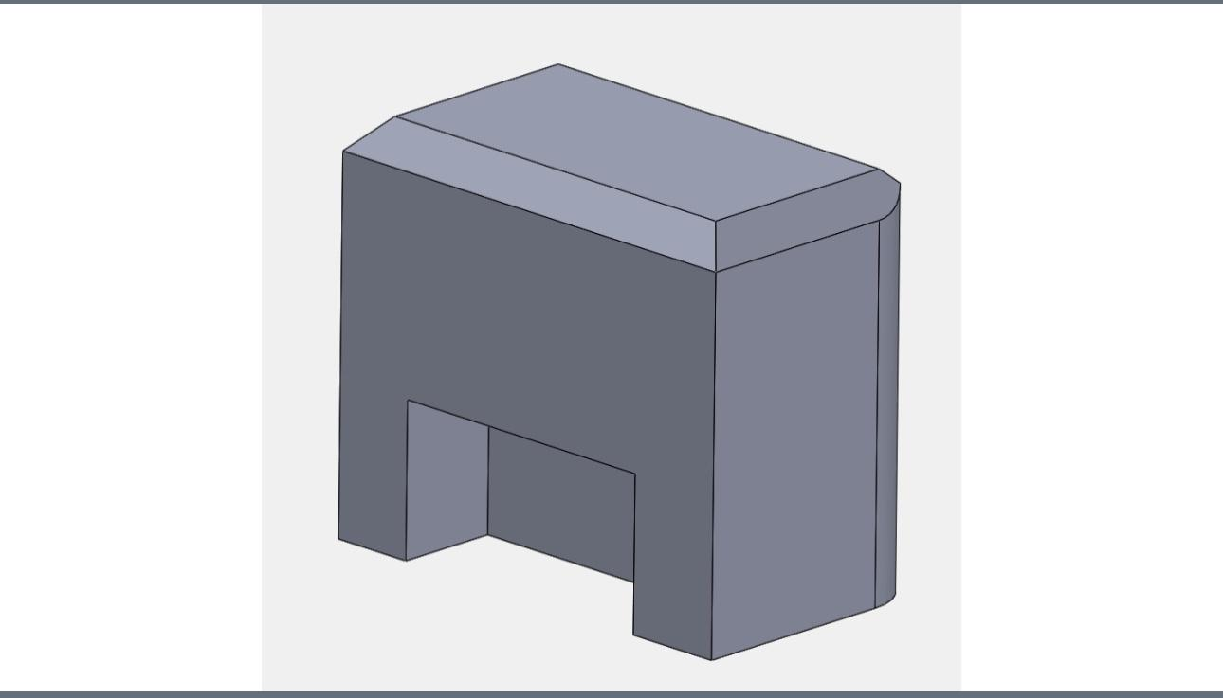
- Opening: U-shaped.
- Walls: Usually two side walls and one bottom wall.
- Bottom: Often flat or curved.
- Example: A U-shaped cut-out along the side of a solid.

Trapezoidal Notch Subtraction
# Source: AI Source: Provided by: [Data Path: Persons Table -> ID Column: 1, Name_En Column: Motasem Essam] -> From: [ChatGPT] on [7/25/2026]
Material is removed to create a trapezoidal cut-out.
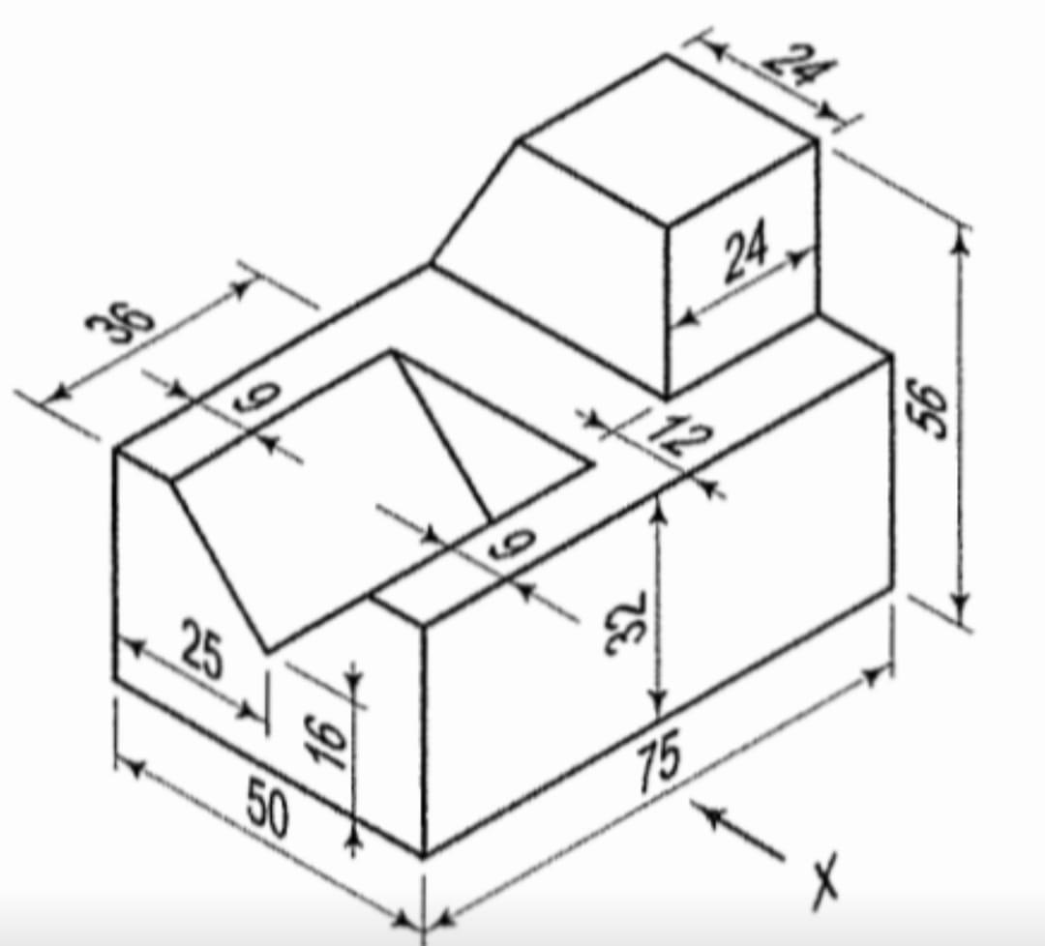
- Opening: Trapezoidal.
- Walls: May be inclined or vertical.
- Example: A trapezoidal indentation in a prism.

Polygonal Notch Subtraction
# Source: AI Source: Provided by: [Data Path: Persons Table -> ID Column: 1, Name_En Column: Motasem Essam] -> From: [ChatGPT] on [7/25/2026]
Material is removed in the form of a polygonal region.
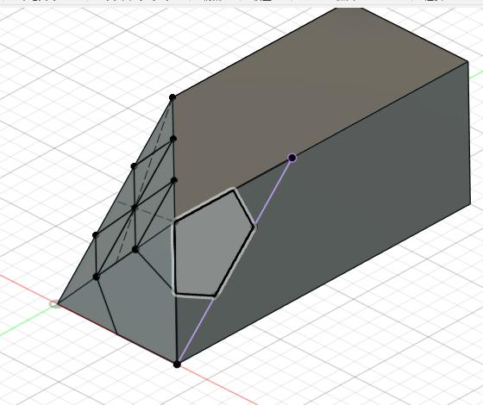
- Opening: Polygonal.
- Walls: Correspond to the sides of the polygon.
- Example: A pentagonal or hexagonal cut-out along a solid boundary.

Curved Notch Subtraction
# Source: AI Source: Provided by: [Data Path: Persons Table -> ID Column: 1, Name_En Column: Motasem Essam] -> From: [ChatGPT] on [7/25/2026]
Material is removed to create a notch with curved boundaries or surfaces.
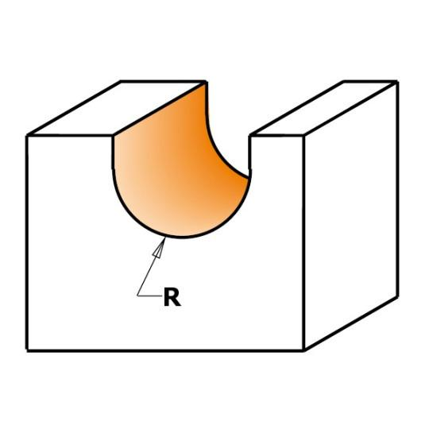
- Opening: Semicircular, elliptical, or irregularly curved.
- Walls: Curved or mixed.
- Example: A semicircular notch along the edge of a block.

Irregular Notch Subtraction
# Source: AI Source: Provided by: [Data Path: Persons Table -> ID Column: 1, Name_En Column: Motasem Essam] -> From: [ChatGPT] on [7/25/2026]
Material is removed to create an irregularly shaped cut-out.
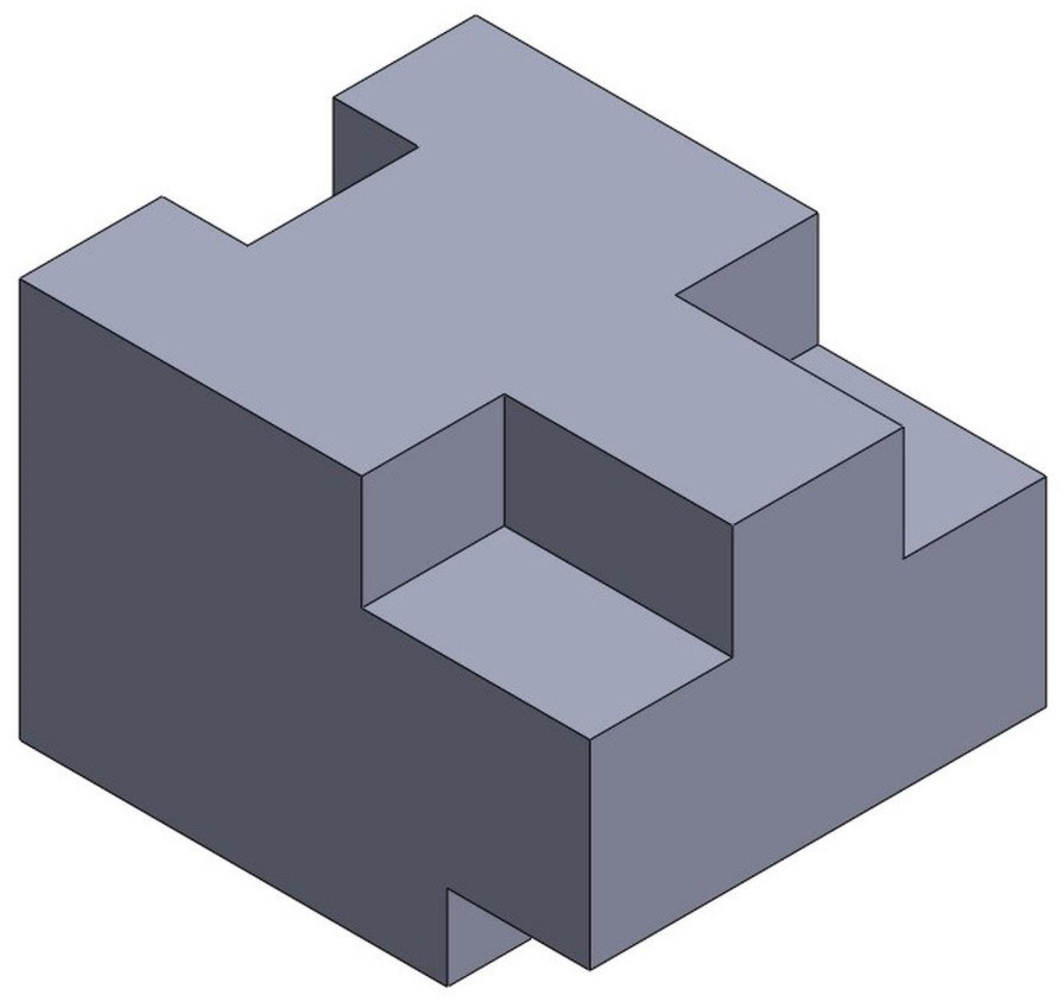
- Opening: Irregular.
- Walls: May be flat, curved, or mixed.
- Example: An irregular cut-out along a solid's boundary.

Classification by Position
# Source: AI Source: Provided by: [Data Path: Persons Table -> ID Column: 1, Name_En Column: Motasem Essam] -> From: [ChatGPT] on [7/25/2026]
Notches can be classified according to where material is removed from the original solid.

Edge Notch
# Source: AI Source: Provided by: [Data Path: Persons Table -> ID Column: 1, Name_En Column: Motasem Essam] -> From: [ChatGPT] on [7/25/2026]
A portion of material is removed along an edge shared by two faces.
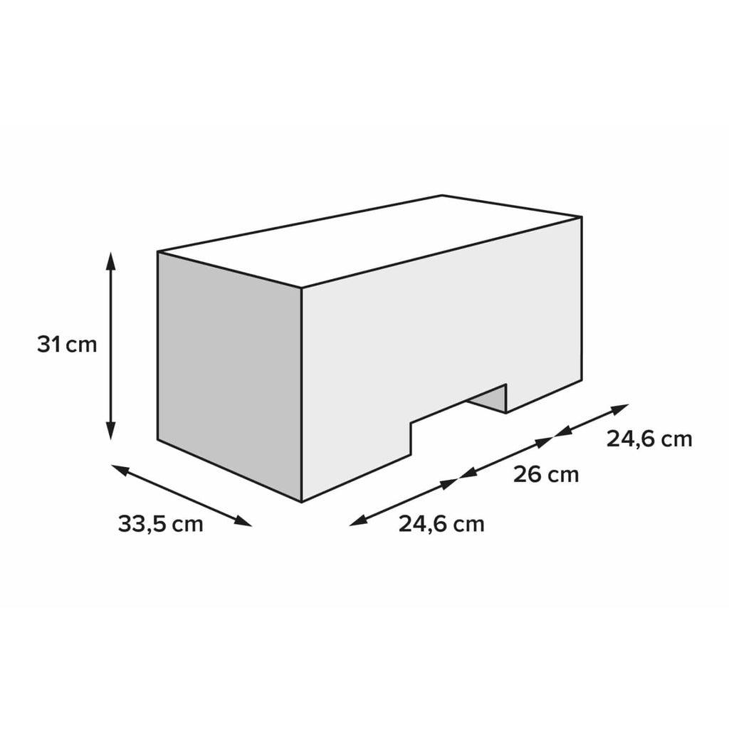

Corner Notch
# Source: AI Source: Provided by: [Data Path: Persons Table -> ID Column: 1, Name_En Column: Motasem Essam] -> From: [ChatGPT] on [7/25/2026]
Material is removed from a corner where three or more faces meet.
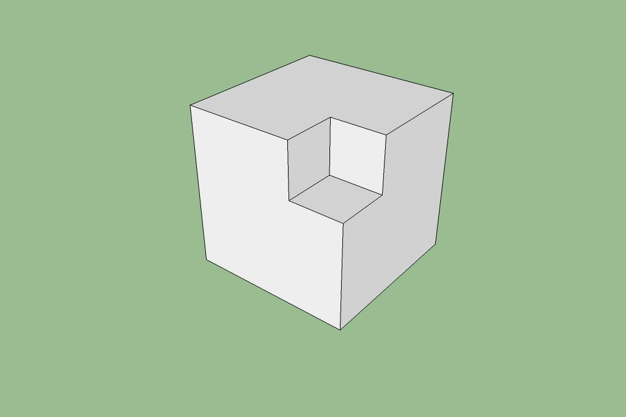

Side Notch
# Source: AI Source: Provided by: [Data Path: Persons Table -> ID Column: 1, Name_En Column: Motasem Essam] -> From: [ChatGPT] on [7/25/2026]
A cut-out is created along one side of a solid.
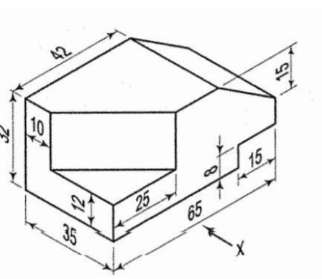

Top-Edge Notch
# Source: AI Source: Provided by: [Data Path: Persons Table -> ID Column: 1, Name_En Column: Motasem Essam] -> From: [ChatGPT] on [7/25/2026]
Material is removed from the upper boundary of a solid.

Bottom-Edge Notch
# Source: AI Source: Provided by: [Data Path: Persons Table -> ID Column: 1, Name_En Column: Motasem Essam] -> From: [ChatGPT] on [7/25/2026]
Material is removed from the lower boundary of a solid.
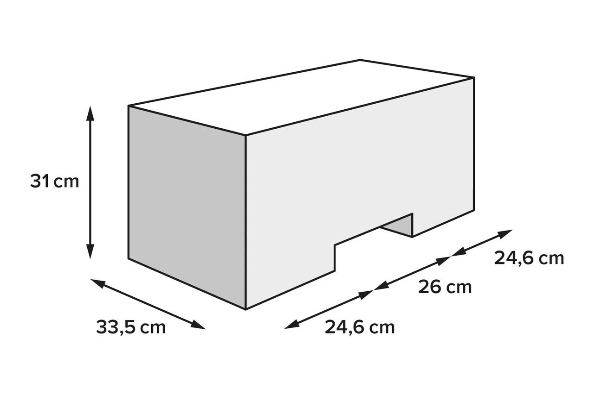

Multiple-Edge Notch
# Source: AI Source: Provided by: [Data Path: Persons Table -> ID Column: 1, Name_En Column: Motasem Essam] -> From: [ChatGPT] on [7/25/2026]
Notches are removed from two or more edges of the same solid.
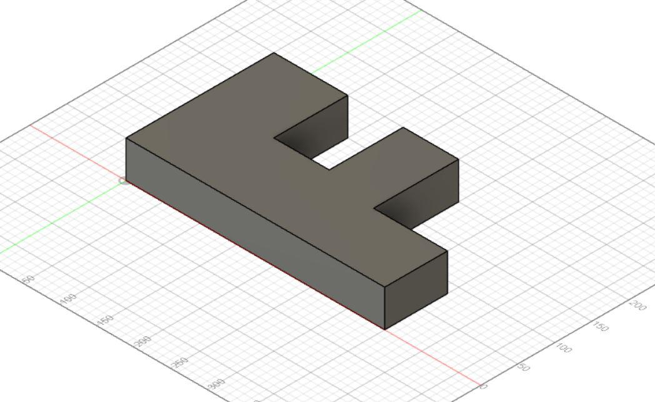

Classification by Cross-Section
# Source: AI Source: Provided by: [Data Path: Persons Table -> ID Column: 1, Name_En Column: Motasem Essam] -> From: [ChatGPT] on [7/25/2026]
The cross-section of a notch describes the shape of the removed region when viewed perpendicular to its cutting direction.
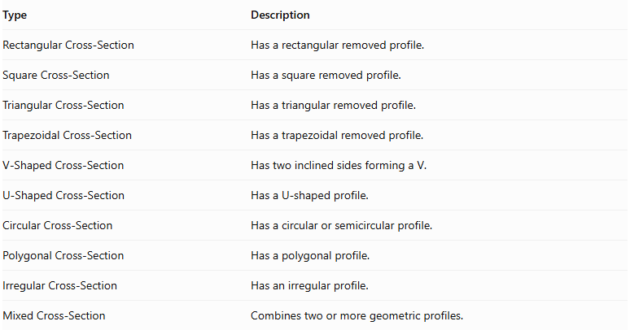
Type | Description
Rectangular Cross-Section | Has a rectangular removed profile.
Square Cross-Section | Has a square removed profile.
Triangular Cross-Section | Has a triangular removed profile.
Trapezoidal Cross-Section | Has a trapezoidal removed profile.
V-Shaped Cross-Section | Has two inclined sides forming a V.
U-Shaped Cross-Section | Has a U-shaped profile.
Circular Cross-Section | Has a circular or semicircular profile.
Polygonal Cross-Section | Has a polygonal profile.
Irregular Cross-Section | Has an irregular profile.
Mixed Cross-Section | Combines two or more geometric profiles.

Classification by Depth and Extent
# Source: AI Source: Provided by: [Data Path: Persons Table -> ID Column: 1, Name_En Column: Motasem Essam] -> From: [ChatGPT] on [7/25/2026]
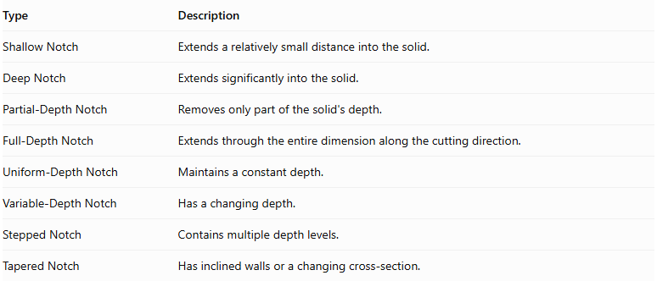
Type | Description
Shallow Notch | Extends a relatively small distance into the solid.
Deep Notch | Extends significantly into the solid.
Partial-Depth Notch | Removes only part of the solid's depth.
Full-Depth Notch | Extends through the entire dimension along the cutting direction.
Uniform-Depth Notch | Maintains a constant depth.
Variable-Depth Notch | Has a changing depth.
Stepped Notch | Contains multiple depth levels.
Tapered Notch | Has inclined walls or a changing cross-section.
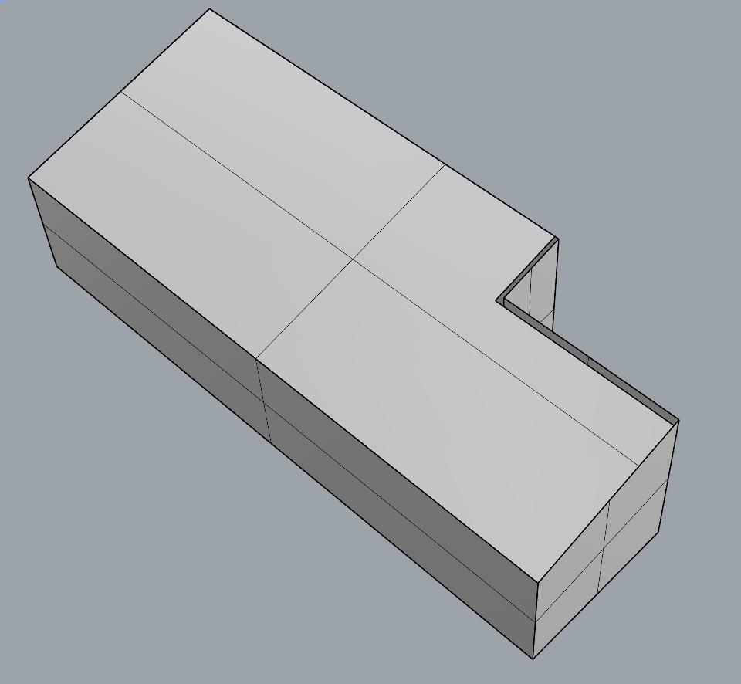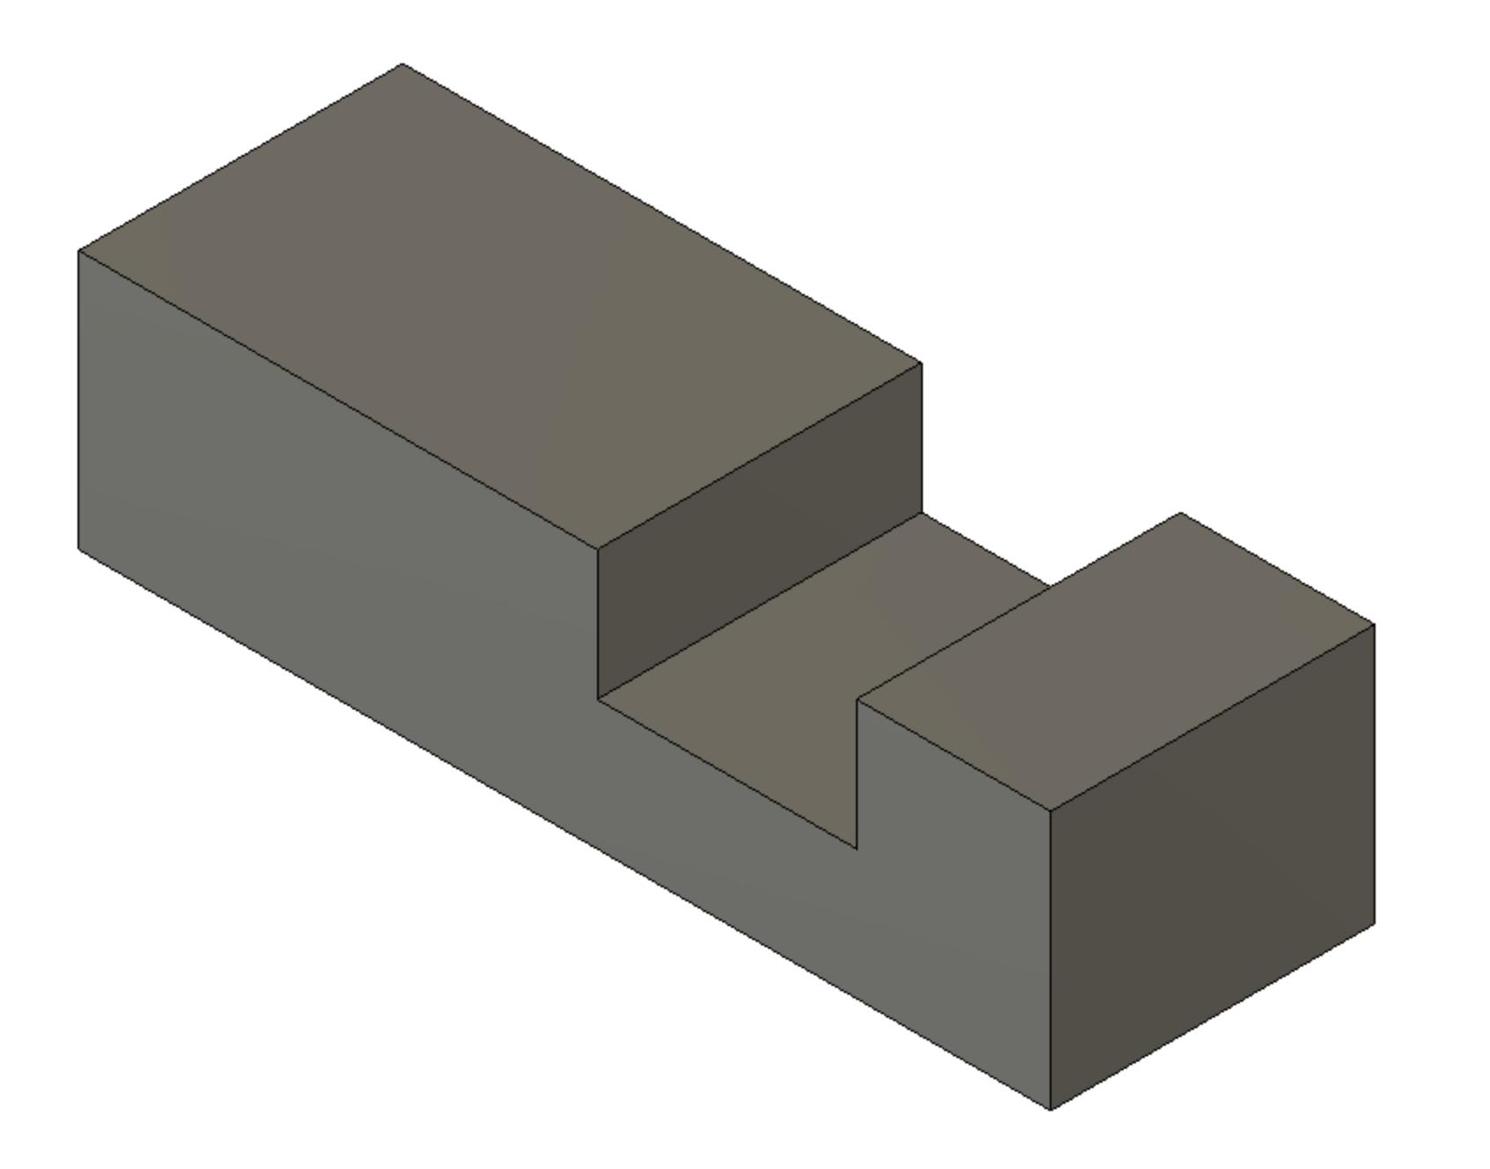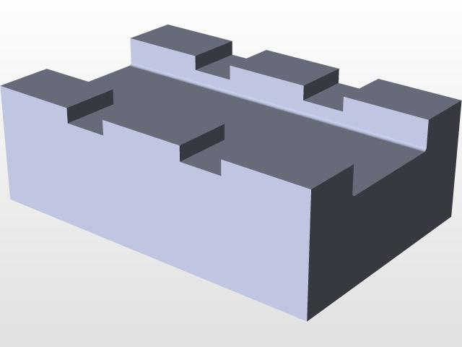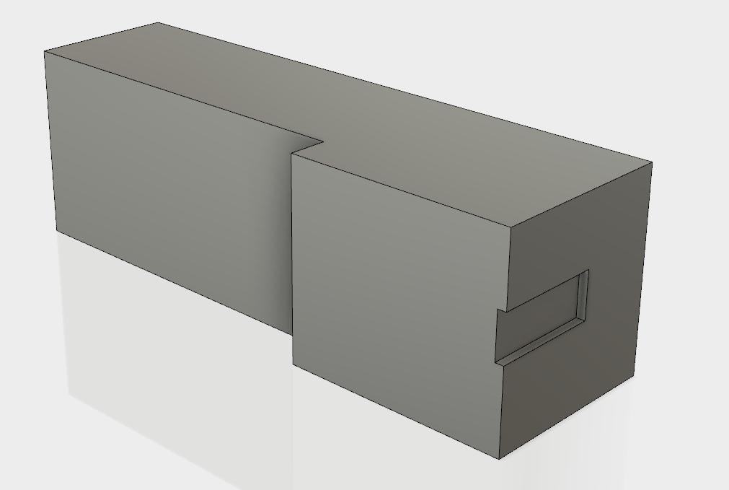
Important: A full-depth notch can extend through the entire thickness of a solid while remaining open to the exterior along an edge. It is therefore not necessarily a through-hole.

Classification by Number and Arrangement
# Source: AI Source: Provided by: [Data Path: Persons Table -> ID Column: 1, Name_En Column: Motasem Essam] -> From: [ChatGPT] on [7/25/2026]
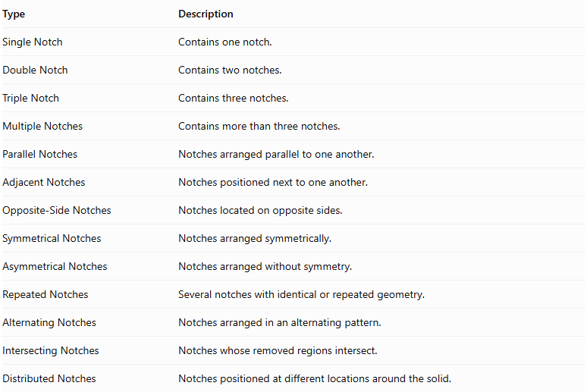
Type | Description
Single Notch | Contains one notch.
Double Notch | Contains two notches.
Triple Notch | Contains three notches.
Multiple Notches | Contains more than three notches.
Parallel Notches | Notches arranged parallel to one another.
Adjacent Notches | Notches positioned next to one another.
Opposite-Side Notches | Notches located on opposite sides.
Symmetrical Notches | Notches arranged symmetrically.
Asymmetrical Notches | Notches arranged without symmetry.
Repeated Notches | Several notches with identical or repeated geometry.
Alternating Notches | Notches arranged in an alternating pattern.
Intersecting Notches | Notches whose removed regions intersect.
Distributed Notches | Notches positioned at different locations around the solid.
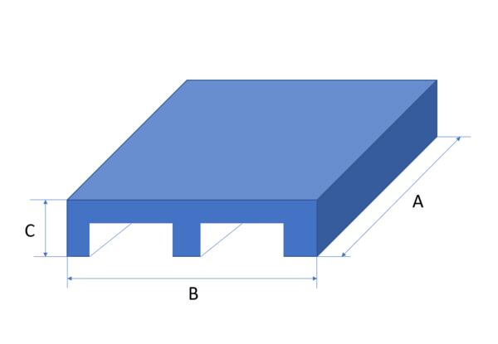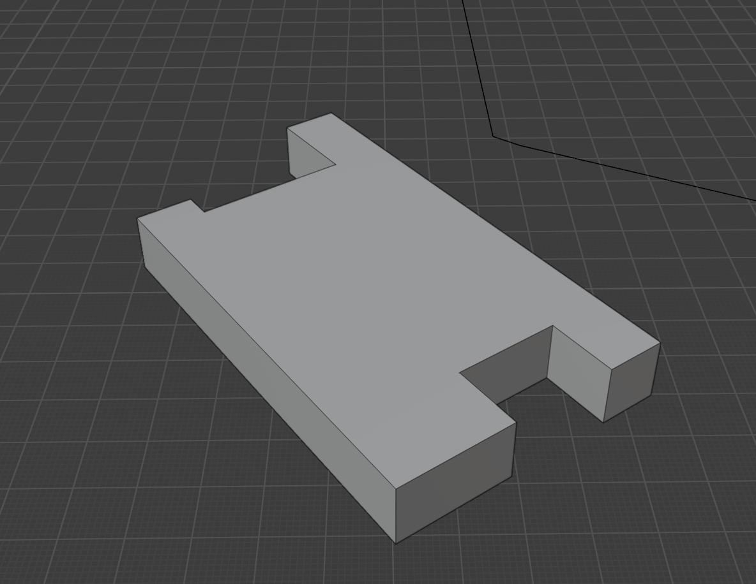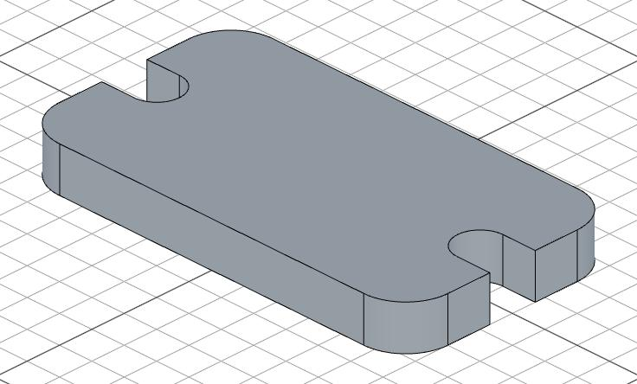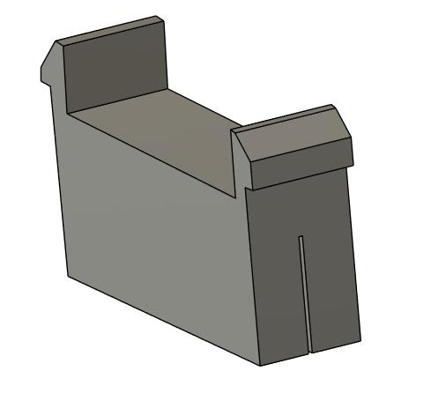

Mathematical Properties and Formulas

Remaining Volume
# Source: AI Source: Provided by: [Data Path: Persons Table -> ID Column: 1, Name_En Column: Motasem Essam] -> From: [ChatGPT] on [7/25/2026]
The remaining volume is obtained by subtracting the removed notch volume from the original solid volume.
$$\boxed{V_{r}=V_{o}-V_{n}}$$
Where:
- $V_{r}$ = Remaining volume.
- $V_{o}$ = Original solid volume.
- $V_{n}$ = Removed notch volume.
For multiple non-overlapping notches:
$$\boxed{V_{r}=V_{o}-\sum_{i=1}^{n}{V_{n_{i}}}}$$
If removed regions overlap, their common volume must be accounted for to avoid double-counting.

Common Notch Volume Formulas
# Source: AI Source: Provided by: [Data Path: Persons Table -> ID Column: 1, Name_En Column: Motasem Essam] -> From: [ChatGPT] on [7/25/2026]
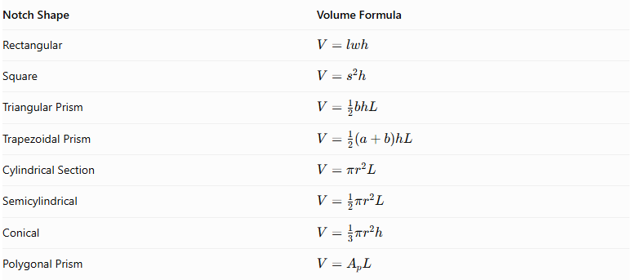
Notch Shape | Volume Formula
Rectangular | $$V=lwh$$
Square | $$V=s^{2}h$$
Triangular Prism | $$V=\frac{1}{2}bhL$$
Trapezoidal Prism | $$V=\frac{1}{2}(a+b)hL$$
Cylindrical Section | $$V=πr^{2}L$$
Semicylindrical | $$V=\frac{1}{2}πr^{2}L$$
Conical | $$V=\frac{1}{3}πr^{2}h$$
Polygonal Prism | $$V=A_{pL}$$
Where:
- $l$ = Notch length.
- $w$ = Notch width.
- $h$ = Notch depth or cross-sectional height, as defined for the particular formula.
- $s$ = Square side length.
- $b$ = Triangle base.
- $L$ = Length along the notch's extrusion direction.
- $a,b$ = Parallel sides of a trapezoidal cross-section.
- $r$ = Radius.
- $A_{p}$ = Area of the polygonal cross-section.

Surface Area
# Source: AI Source: Provided by: [Data Path: Persons Table -> ID Column: 1, Name_En Column: Motasem Essam] -> From: [ChatGPT] on [7/25/2026]
Unlike volume, surface area cannot be calculated by simply subtracting the notch's complete surface area from the original solid's surface area.
The correct approach is:
$$\boxed{{SA}_{r}={SA}_{o}-A_{removed}+A_{new}}$$
Where:
- ${SA}_{r}$ = Remaining external surface area.
- ${SA}_{o}$ = Original external surface area.
- $A_{removed}$ = Original exterior surface area removed by the notch.
- $A_{new}$ = Newly exposed surfaces created by the notch.
For a rectangular notch with dimensions $l,w,d$, where it removes a rectangular section through a side boundary:
$$A_{new}=A_{bottom}+A_{walls}$$
The precise formula depends on which original faces are cut and which new surfaces become exposed.

Worked Examples

Example 1: Rectangular Edge Notch
# Source: AI Source: Provided by: [Data Path: Persons Table -> ID Column: 1, Name_En Column: Motasem Essam] -> From: [ChatGPT] on [7/25/2026]
A rectangular prism has dimensions:
- Length = 12 cm
- Width = 8 cm
- Height = 6 cm
A rectangular notch is removed from one corner with dimensions:
- Length = 4 cm
- Width = 3 cm
- Height = 2 cm
Assume the notch is cut from a corner and extends across the specified three dimensions.
Find the remaining volume and surface area.
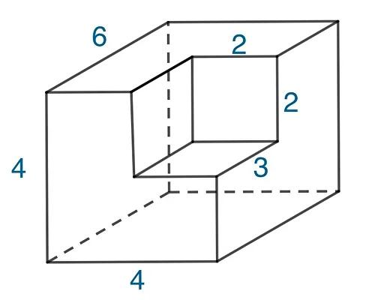
Step 1: Calculate the original volume.
$$V_{o}=12×8×6$$
$$V_{o}=576{ cm}^{3}$$
Step 2: Calculate the removed volume.
$$V_{n}=4×3×2$$
$$V_{n}=24{ cm}^{3}$$
Step 3: Calculate the remaining volume.
$$V_{r}=576-24$$
$$\boxed{V_{r}=552{ cm}^{3}}$$
Step 4: Calculate the original surface area.
$${SA}_{o}=2(lw+lh+wh)$$
$$=2(96+72+48)$$
$${SA}_{o}=432{ cm}^{2}$$
Step 5: Calculate the remaining surface area.
Because the notch is removed from a corner, three original rectangular regions disappear:
$$A_{removed}=(4×3)+(4×2)+(3×2)$$
$$=12+8+6=26{ cm}^{2}$$
Three new internal rectangular surfaces are exposed:
$$A_{new}=(4×3)+(4×2)+(3×2)$$
$$=26{ cm}^{2}$$
Therefore:
$${SA}_{r}=432-26+26$$
$$\boxed{{SA}_{r}=432{ cm}^{2}}$$
Final Answer:
- Remaining Volume = 552 cm³
- Remaining Surface Area = 432 cm²
The surface area remains unchanged because the three removed exterior rectangular areas are replaced by three equal-area internal surfaces.

Example 2: Triangular Edge Notch
# Source: AI Source: Provided by: [Data Path: Persons Table -> ID Column: 1, Name_En Column: Motasem Essam] -> From: [ChatGPT] on [7/25/2026]
A rectangular prism has dimensions:
- Length = 10 cm
- Width = 8 cm
- Height = 6 cm
A triangular-prism notch is removed from one longitudinal edge. Its triangular cross-section has:
- Base = 4 cm
- Height = 3 cm
- Length = 10 cm
Find the remaining volume and surface area.
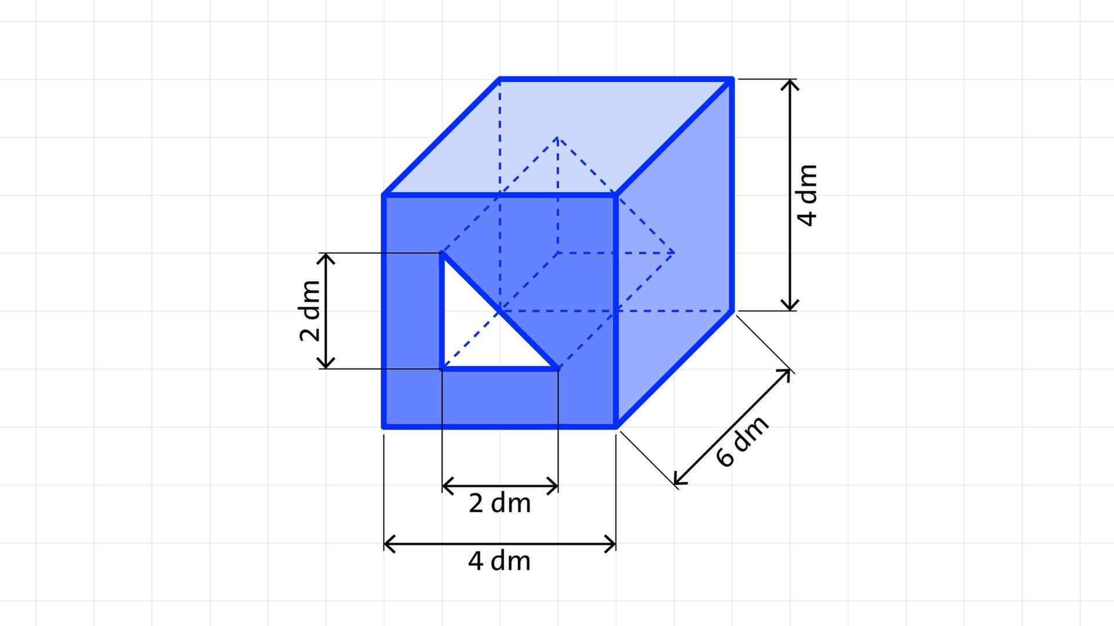
Step 1: Calculate the original volume.
$$V_{o}=10×8×6$$
$$V_{o}=480{ cm}^{3}$$
Step 2: Calculate the removed triangular-prism volume.
$$V_{n}=\frac{1}{2}bhL$$
$$=\frac{1}{2}(4)(3)(10)$$
$$V_{n}=60{ cm}^{3}$$
Step 3: Calculate the remaining volume.
$$V_{r}=480-60$$
$$\boxed{V_{r}=420{ cm}^{3}}$$
Step 4: Calculate the original surface area.
$${SA}_{o}=2(10×8+10×6+8×6)$$
$$=2(80+60+48)$$
$${SA}_{o}=376{ cm}^{2}$$
Step 5: Calculate the remaining surface area.
Assume the triangular notch is cut from the upper longitudinal edge, removing a right-triangular cross-section with legs 4 cm and 3 cm.
The removed original surface regions are:
- Top rectangular strip: $10×4=40{ cm}^{2}$
- Side rectangular strip: $10×3=30{ cm}^{2}$
The newly exposed sloping rectangular wall has width:
$$c=\sqrt{4^{2}+3^{2}}=5 cm$$
Its area is:
$$A_{new}=10×5=50{ cm}^{2}$$
The two end triangular regions removed from the original end faces are replaced by the corresponding new end boundaries, so their areas cancel.
Therefore:
$${SA}_{r}=376-40-30+50$$
$$\boxed{{SA}_{r}=356{ cm}^{2}}$$
Final Answer:
- Remaining Volume = 420 cm³
- Remaining Surface Area = 356 cm²

Important Characteristics
# Source: AI Source: Provided by: [Data Path: Persons Table -> ID Column: 1, Name_En Column: Motasem Essam] -> From: [ChatGPT] on [7/25/2026]
- Material is removed from an edge, corner, or boundary region.
- The resulting solid has an open indentation or cut-out.
- A notch is generally connected to the exterior through at least one boundary opening.
- Notches can have rectangular, triangular, square, trapezoidal, curved, or irregular shapes.
- They can be shallow, deep, full-depth, stepped, or tapered.
- A notch may remove material from one edge or several edges.
- Multiple notches can be arranged symmetrically, asymmetrically, or in repeated patterns.
- The remaining volume is smaller than the original volume.
- The surface area may increase, decrease, or remain unchanged, depending on the geometry.
- A notch does not necessarily create an enclosed hole or cavity.

Comparison with Other Subtraction Methods
# Source: AI Source: Provided by: [Data Path: Persons Table -> ID Column: 1, Name_En Column: Motasem Essam] -> From: [ChatGPT] on [7/25/2026]
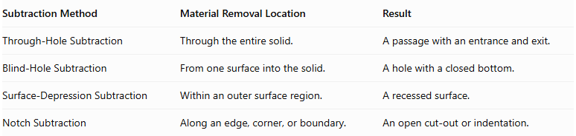
Subtraction Method | Material Removal Location | Result
Through-Hole Subtraction | Through the entire solid. | A passage with an entrance and exit.
Blind-Hole Subtraction | From one surface into the solid. | A hole with a closed bottom.
Surface-Depression Subtraction | Within an outer surface region. | A recessed surface.
Notch Subtraction | Along an edge, corner, or boundary. | An open cut-out or indentation.
Important distinction: The defining feature of a notch is its connection to an external boundary. A surface depression is generally surrounded by the original surface, whereas a notch opens through an edge or boundary.

Applications
# Source: AI Source: Provided by: [Data Path: Persons Table -> ID Column: 1, Name_En Column: Motasem Essam] -> From: [ChatGPT] on [7/25/2026]
Notch subtraction is commonly used in:
- Mechanical engineering: slots and fitting cut-outs.
- Construction: notched beams and structural joints.
- Carpentry: corner notches and interlocking wood joints.
- Manufacturing: edge cut-outs and material clearance.
- Architecture: recessed corners and structural detailing.
- Product design: assembly gaps and component fitting.
- Packaging: edge cut-outs and interlocking sections.
- Engineering models: modifying solid boundaries to create complex shapes.

Key Points
# Source: AI Source: Provided by: [Data Path: Persons Table -> ID Column: 1, Name_En Column: Motasem Essam] -> From: [ChatGPT] on [7/25/2026]
- Notch subtraction removes material from an edge, corner, or boundary.
- It produces an open cut-out rather than an enclosed hole.
- Notches can be classified by shape, position, cross-section, depth, and arrangement.
- Remaining volume equals original volume minus removed volume, with overlap corrections if needed.
- Surface-area calculations must account for the original exterior areas removed and the new surfaces exposed.
- A full-depth notch can pass through the entire thickness while remaining open to the exterior.

Conclusion
# Source: AI Source: Provided by: [Data Path: Persons Table -> ID Column: 1, Name_En Column: Motasem Essam] -> From: [ChatGPT] on [7/25/2026]
Notch Subtraction is a classification of composite solids formed by removing material from the edges, corners, or boundaries of an existing solid. It creates open geometric cut-outs that modify the original external shape.
Notches can have different geometric profiles, depths, positions, and arrangements. Their volume and surface area can be calculated by analyzing the removed region and the newly exposed surfaces.

